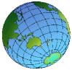
On My World Travels

In the summer I went on a world shopping trip. In each country I visited I changed some sterling into the local currency and bought something to remind me of that country. The exchange rate is shown below.

Currency | £1 buys
Cypriot Pound | 0.85
Dollar | 1.54
Euro | 1.52
Maltese Pound | 0.62
Swedish Krona | 13.49
Thailand Baht | 63.14
Turkish Lira | 2,508,700

Here are some of the things that I bought, but how much did I pay in sterling?


I bartered for the Turkish rug and paid 200,000,000 Turkish lira

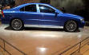
In Sweden I picked up a Volvo for SKr 263,055

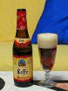
In Belgium a bottle of Leffe cost 2.50 Euros



In New York some designer glasses were just $50.00

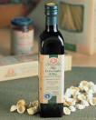
Back in Europe my bottle of Olive Oil from Cyprus cost 1.50 Cypriot pounds. I also bought an olive wood bowl for 4 Cypriot pounds
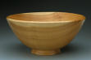

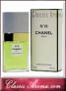
Next I was in Paris where a bottle of Channel No.5 set me back 100 Euros

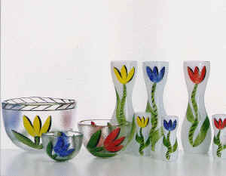
Returning to Stockholm some Kosta Boda glassware was a steal at just Skr 500

I went to Malta for some jewellery. The silver Maltese cross was 5 Maltese pounds
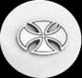
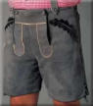

I couldn’t resist a pair of Ledehosen in Germany for 90 euros

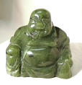

And for some spiritual well being a Buddha carved from jade cost 400 Thai Bahts

Sadly my travelling companion just bought a Big Mac in every country. As my friend is a bit tight she always calculated the sterling price of the burger, but how much local currency did she have to hand over?
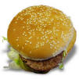
Country | Sterling price | Local price
Belgium | £1.50
Cyprus | £1.25
France | £2.05
Germany | £1.80
Malta | £0.90
Sweden | £1.60
Thailand | £1.15
Turkey | £0.80
USA | £1.30

